Estimation theory – project proposal

**Felipe Valdez – MS Student**

**Jonathan Dorsey – MS Student**

**05/06/2019**

**Dynamic System**

The system under investigation is an Li-Ion Battery Management System for Electrified Vehicles (nonlinear). A battery management system (BMS) is responsible for calculating several parameters such as the battery’s state of charge (SOC), state of health (SOH), temperature, state of function (SOF), remaining useful life (RUL) and communicating with other vehicle components and subsystems. The SOC can help estimate current driving range and prevent the battery pack from overcharge and over-discharge. SOH can be used to track capacity and resistance of the battery. RUL is crucial as it determines when a battery should be replaced as well as the potential resell of the battery [1].

These parameters are not easy to calculate for, as it would demand extensive computing times, expensive instrumentation or have the vehicle stopped preventing its application in real time. A solution is to generate estimates of the parameters, which requires a quality model, and good estimation strategy for the various scenarios: temperature, power demands, and state of function. An equivalent circuit model (ECM) and estimation techniques such as Extended Kalman Filter (EKF) and Unscented Kalman Filter (UKF) will be employed to measure important parameters such as SOC, current sensor and voltage biases as described in the next paragraph.

**State Estimation**

The system states to be estimated are the following:

* State 1: SOC
* State 2: Current Sensor Bias
* State 3: Voltage Sensor Bias

**Reason:** State of charge (SOC) estimation is a vital function of the battery management system - the heart of EVs. Due to the non-uniformities in tuning and testing scenarios, quantifying performance of SOC estimation algorithms is difficult. The inherent difficulty in developing accurate and computationally tractable battery models capable of running in real-time, makes knowledge of the exact behavior of the battery and the SOC very difficult to determine within a reasonable accuracy [2]. This proposal would utilize a second order lumped parameter dynamic model as the basis for the electrical dynamics of the battery. SOC estimation algorithms, EKF & UKF, will be developed and tested for a variety of scenarios like varying sensor noise and bias properties, varying state and parameter initializations and possibly different initial cell temperatures. As mentioned above, these parameters are not easy to calculate for, as it would demand extensive computing times, expensive instrumentation or have the vehicle stopped preventing its application in real time. Therefore, using an EKF/UKF estimation technique is vital for the battery’s overall health.

**System Model**

To model the battery, a second-order RC equivalent circuit model will be used to approximate the electrochemical process of the cell using electrical components like resistors and capacitors. Equivalent circuit models (ECMs) are widely used in model-based estimation due to their balance between accuracy and simplicity in implementation; therefore it will be used in this project.

The dynamics of the nonlinear system will be linearized and converted into a discrete state space model to work in Matlab/Simulink environment with an implementation of an EKF/UKF for state estimation.

Battery Model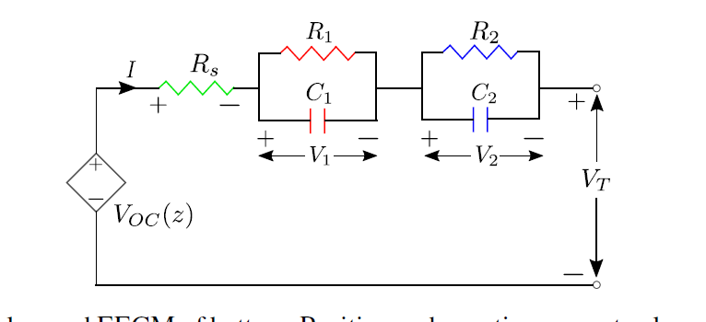

**Inputs**

* Current
* Possibly temperature

**Output**

* Terminal Voltage

**System Equations**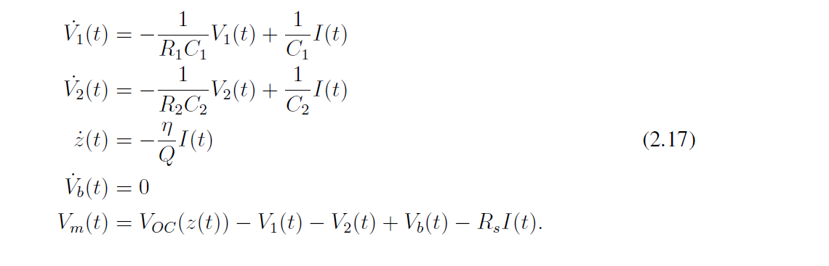

**Uncertainty & Measurement Noise Representation**

Battery Management Systems are typically subject to interference and electrical noise that degrade the performance of the current and voltage sensing accuracy. Additional, current and voltage sensor typical exhibit a bias, these quantities represent the uncertainty of the environment within which the Kalman Filter will be used for estimation.

For sensor noise, random noise blocks can be added in Simulink model both at the input (I) and output (V). Additionally, constant value bias offsets will be added to the model to force the characteristic of drift and bias in the sensors.

**Distribution of Work**

All members will distribute the work evenly (working on the same tasks). This project is not related to any thesis/research/senior design project.

**References**

[1] Bustos, Richard (2018). *State of Charge and Parameter Estimation of Electric Vehicle Batteries.* Master thesis.

[2] Narayan, Anand (2017). *State and Parametric Estimation of Li-Ion Batteries in Electrified Vehicles.* Master thesis.